YD’s DataViz4: Europe Sales analysis over years

Analyze the P1-AmazingMartEU2 data set and perform the following

* Visualize the Profit Margin and Sales of Europe
* Create a Customer Scatter Plot
* Make an interactive dashboard by creating highlight
* Make an interactive dashboard by creating filter

Let’s Do It:

1. Visualize the Profit Margin and Sales of Europe

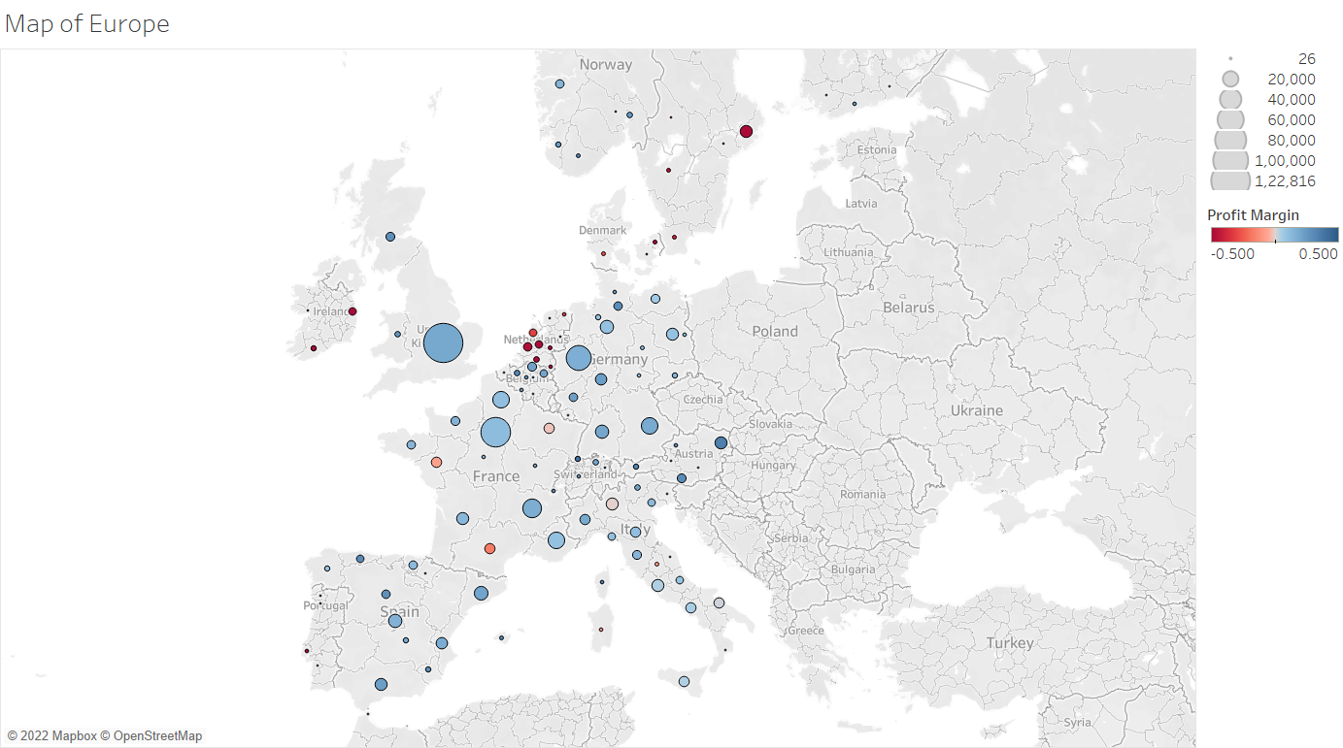

2. Create a Customer Scatter Plot

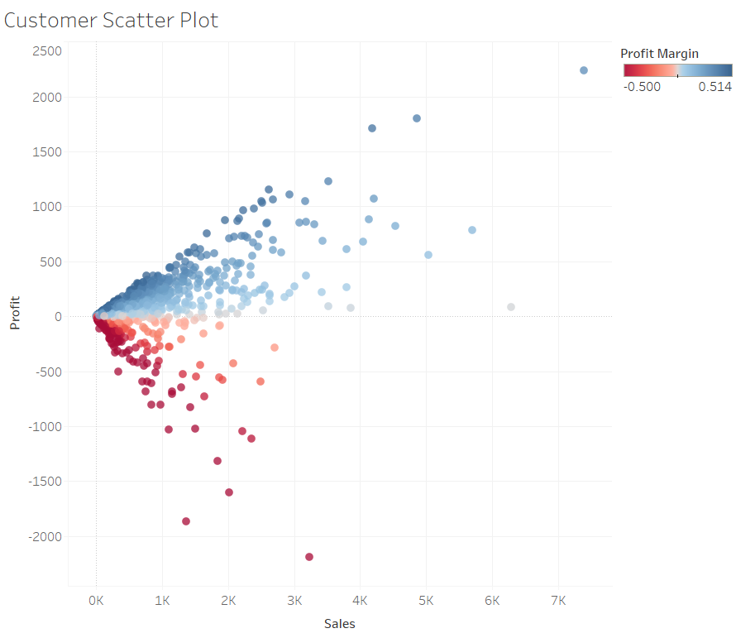

3. Make an interactive dashboard by creating highlight

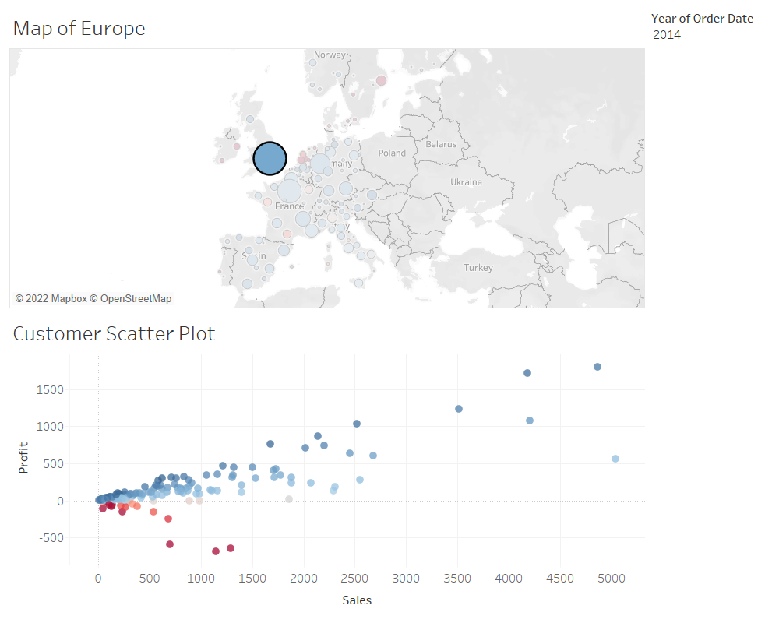

4.Make an interactive dashboard by creating filter

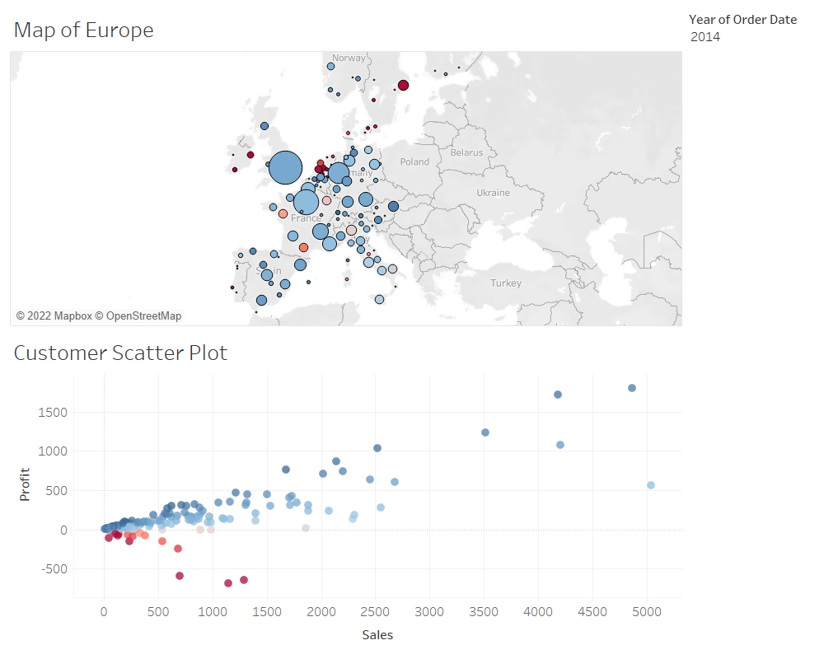

Thanks for reading till the end hope so you liked it leave your opinion about it in the comment section.